Submitted By:-

Prateek Raina-2013CSB1022

Rahul Agrawal-2013CSB1024

Utkarsh Singh Chauhan-2013CSB1036

Shankar Meena-2013CSB1031

Rohit Binjrawat-2013MEB1109

Supervising Faculty:-

Dr. Prabir Sarkar

Course Involved:-

Product Design and Realisation-I (GEL-101)

Abstract

This project is about sustainability of cities. It calculates the percentage of Green, White and Blue colors in the city using their maps. The project has been done using MATLAB and Adobe Photoshop.

Sustainability OF cities

# **Details of Students involved**

|  |  |  |  |  |  |
| --- | --- | --- | --- | --- | --- |
| S.No. | Name of the Student | Entry Number | Email | Phone No. | Interested to be a part of patent application process |
| 1. | Prateek Raina | 2013CSB1022 | prateek.raina@iitrpr.ac.in | +91-9569331022 | Yes |
| 2. | Rahul Agrawal | 2013CSB1024 | rahul.agrawal@iitrpr.ac.in | +91-7837951855 | Yes |
| 3. | Utkarsh Singh Chauhan | 2013CSB1036 | utkarsh.chauhan@iitrpr.ac.in | +91-8591086993 | Yes |
| 4. | Rohit Binjrawat | 2013MEB1109 | rohit.binjrawat@iitrpr.ac.in | +91-8591540271 | Yes |
| 5. | Shankar Meena | 2013CSB1031 | shankar.meena@iitrpr.ac.in | +91-7307233884 | Yes |

# **CERTIFICATION**

We do certify that this report explains the work carried out by us in the course GEL-101, under the overall supervision of Dr. Prabir Sarkar. The contents of the report including text, figures, tables, computer programs, etc. have not been reproduced from other sources such as books, journals, magazines, reports, manuals, websites, etc. Wherever limited reproduction from another source has been made, the source has been duly acknowledged at that point and also listed in the References.

Prateek Raina-2013CSB1022

Rahul Agrawal-2013CSB1024

Utkarsh Singh Chauhan-2013CSB1036

Shankar Meena-2013CSB1031

Rohit Binjrawat-2013MEB1109

# **ACKNOWLEDGEMENT**

We would like to express my sincere thanks & gratitude to Dr. Prabir Sarkar for his continuous and unrelenting support, guidance and help, which have been invaluable during the course of this project. We also want to thank all those who have helped in the successful completion of this project.

Prateek Raina-2013CSB1022

Rahul Agrawal-2013CSB1024

Utkarsh Singh Chauhan-2013CSB1036

Shankar Meena-2013CSB1031

Rohit Binjrawat-2013MEB1109

# **1. INTRODUCTION**

A **sustainable city**, or **eco-city** is a city designed with consideration of environmental impact, inhabited by people dedicated to minimization of required inputs of energy, water and food, and waste output of heat, air pollution - CO2, methane, and water pollution. Richard Register first coined the term "ecocity" in his 1987 book, *Ecocity Berkeley: Building Cities for a Healthy Future*. Other leading figures who envisioned the sustainable city are architect Paul F Downton, who later founded the company Ecopolis Pty Ltd, and authors Timothy Beatley and Steffen Lehmann, who have written extensively on the subject. The field of industrial ecology is sometimes used in planning these cities.

There remains no completely agreed upon definition for what a sustainable city should be or completely agreed upon paradigm for what components should be included. Generally, developmental experts agree that a sustainable city should meet the needs of the present without sacrificing the ability of future generations to meet their own needs. The ambiguity within this idea leads to a great deal of variation in terms of how cities carry out their attempts to become sustainable. However, a sustainable city should be able to feed itself with minimal reliance on the surrounding countryside, and power itself with renewable sources of energy. The crux of this is to create the smallest possible ecological footprint, and to produce the lowest quantity of pollution possible, to efficiently use land; compost used materials, recycle it or convert waste-to-energy, and thus the city's overall contribution to climate change will be minimal, if such practices are adhered to.

# **1.1 PROBLEM**

In today’s world, where the scientists are predicting the end of the world by calamities due to alarming increasing temperatures of the earth, the melting of ice in the various glaciers of the world, the change in the solar output and so on; and even the imagination of the common man catching up pace with these not so unrealistic ideas, no one can deny the significant importance that the vegetation has in stabilising the earth. From small benefits like providing for the basic necessities of food, clothing and shelter for man, and directly or indirectly for any human being; to large impacts like maintaining the levels of greenhouse gases like carbon dioxide and thus preventing global warming; no doubt, these living beings have played a major role in the sustainability of the earth.

The decreasing vegetation and the increase in water consumption and population all around the world, especially, in the highly populous cities is the main region of concern for this project.

# **1.2 IMPORTANCE OF SOLVING THIS PROBLEM**

Human beings use resources provided by nature. Scientific advances have enabled human beings to harness these resources of nature for their well-being. For example, human beings use water and coal to produce electricity which in turn helps us to provide heat and light for our homes. 

In the recent past, human beings have been blatantly polluting the environment. Current trends also indicate that human beings are consuming resources without giving time for nature to replenish them. This is what is creating problems.   
  
Water is an important natural resource. Less than 2 percent of the water on our planet is fresh water. Most of this fresh water is being polluted. Nearly 900 million people do not have access to water that is free from industrial waste and disease causing germs. People have to walk miles every day to fetch drinking water. We should remember these facts when we let the water flow from the tap when we brush our teeth or when we shave or when we stand under the shower just for pleasure. Water is becoming scarce. Individuals and the governments all over the world should work in conserving this valuable resource. We should seriously consider harvesting rain water. We should plug all those leaks in our homes because 8% of all home water is wasted through leaks.

Ozone layer protects us from harmful radiation emitting from the sun. These ultraviolet rays can cause skin cancer in human beings. They also reduce immunity in human beings and animals and cause considerable damage to plant life. Plankton in the ocean will be reduced due to these dangerous rays. Chlorofluorocarbons are depleting ozone layer. These are used extensively in various industries. These should be replaced before further damage is caused.

Trees should be allowed to grow. They help in reducing air temperature, remove pollutants from the atmosphere, provide us with oxygen, reduce noise pollution and most important, decrease soil erosion. Sometimes it becomes necessary to cut down trees. This should be made up by planting more trees.

# **1.3 OVERVIEW OF THE PROJECT**

This project calculates the percentage of Green, White and Blue color of 45 cities across the world. Green region depicts the vegetation of that city. Larger the percentage of green in the city, more sustainable is the city.

White region depicts the various structures like concrete structures, buildings, etc. in the city. Blue region tells us about the water bodies in the city. These water bodies may include lakes, rivers etc.

Higher the percentage of green and blue and lower the percentage of white in the city, more sustainable is the city. The percentage of these colors was calculated using two different softwares:-

1. MATLAB R2013a
2. Adobe Photoshop CS6

The results from both of these softwares were collected and tabulated. The results were then compared and several conclusions were drawn from these results. The obtained results were also compared with the actual data from the Internet. However, the actual data for many of the cities was not found on the Internet.

**NOTE: -** Apart from MATLAB R2013a & Adobe Photoshop CS6, Google Earth Pro was also used to get the maps.

# **2. OBJECTIVES**

The main objective of this project is to determine the percentage green, white and blue color in a city using its map. The project covers 45 cities across the world. 20 cities are one of the most populated cities in the world. The green color indicates vegetation cover, white color indicates concrete region and the blue color indicates the region covered by water bodies. The project aims to bring forward the issue that there are many cities in the world where there is very less percentage of greenery.

# **2.1 EXPLANATION OF THE PROBLEM**

The term *sustainable development* rose to significance after it was used by the Brundtland Commission in its 1987 report Our Common Future. In the report, the commission coined what has become the most often-quoted definition of sustainable development: "development that meets the needs of the present without compromising the ability of future generations to meet their own needs."

**Global warming** refers to an unequivocal and continuing rise in the average temperature of Earth's climate system. Since 1971, 90% of the warming has occurred in the oceans. Despite the oceans' dominant role in energy storage, the term "global warming" is also used to refer to increases in average temperature of the *air and sea at Earth's surface*. Since the early 20th century, the global air and sea surface temperature has increased about 0.8 °C (1.4 °F), with about two-thirds of the increase occurring since 1980. Each of the last three decades has been successively warmer at the Earth's surface than any preceding decade since 1850.

Changes have been observed in the amount, intensity, frequency, and type of precipitation. Widespread increases in heavy precipitation have occurred, even in places where total rain amounts have decreased. With medium confidence, IPCC (2012) concluded that human influences had contributed to an increase in heavy precipitation events at the global scale.

Over most land areas since the 1950s, it is very likely that there have been fewer and/or warmer cold days and nights. Hot days and nights have also very likely become warmer and/or more frequent. Human activities have very likely contributed to these trends. There may have been changes in other climate extremes (e.g., floods, droughts and tropical cyclones) but these changes are more difficult to identify. Projections suggest changes in the frequency and intensity of some extreme weather events. Confidence in projections varies over time.

Some evidence suggests that droughts have been occurring more frequently because of global warming and they are expected to become more frequent and intense in Africa, southern Europe, Middle East, most of the America, Australia, and Southeast Asia. However, other research suggests that there has been little change in drought over the past 60 years. Their impacts are aggravated because of increased water demand, population growth, urban expansion, and environmental protection efforts in many areas. Droughts result in crop failures and the loss of pasture grazing land for livestock.

# **2.2 METHODOLOGY**

The project involved the following steps:-

1. **Determination of percentage of colors using MATLAB**
2. The maps were downloaded from Google Maps. Some of the maps were downloaded from Google Earth Pro. Different parts of the map were downloaded at a height of 2000 ft. Instead of using Print Screen, Snipping Tool was used for better and accurate maps. The image shown below shows a part snipped using the Snipping Tool. Similarly other parts were also obtained for a city.

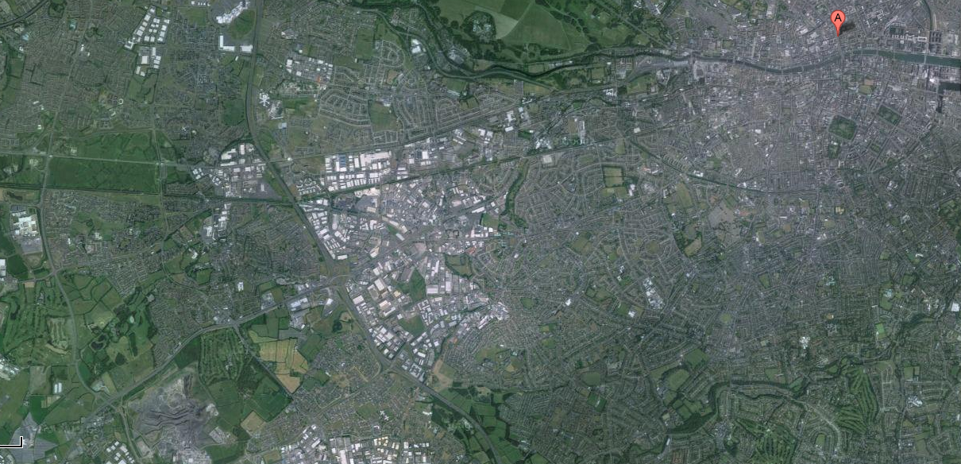

1. After getting different parts of the same map using Snipping Tool, a single map was obtained using Photomerge Tool in Adobe Photoshop CS6. The image shown below shows a fully combined map and usage of Photomerge Tool.

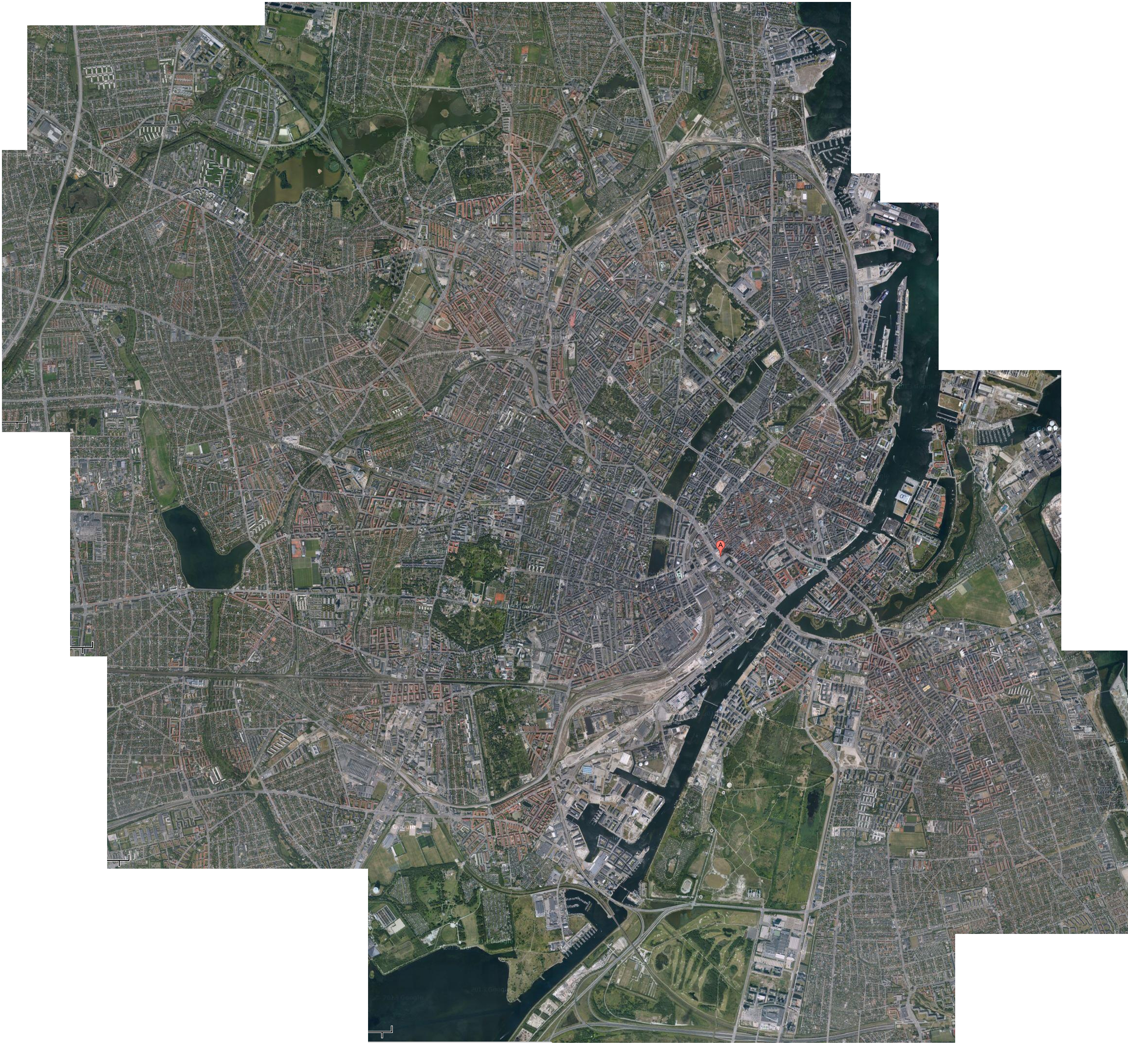

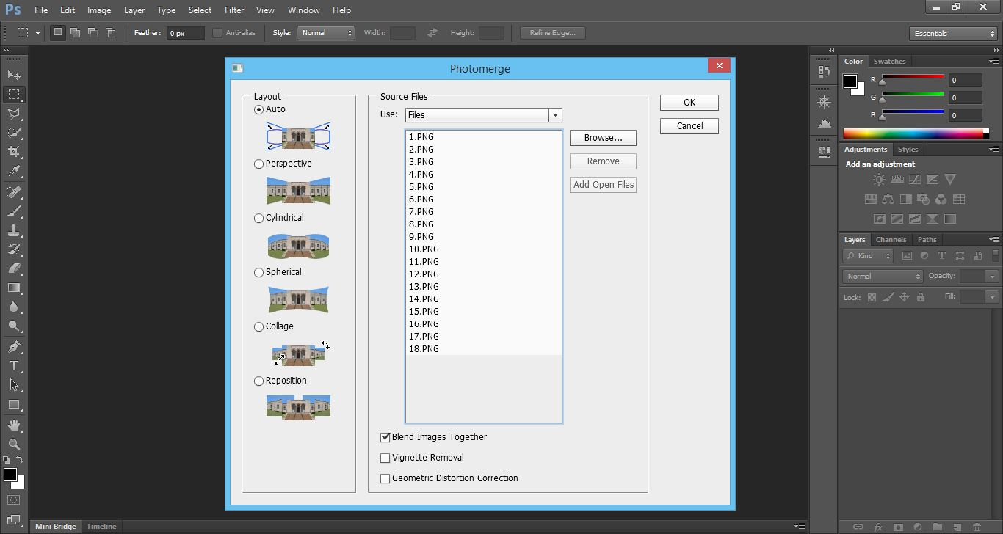

1. After obtaining the combined map, the image was input in the MATLAB code. A particular range for RGB values was selected and a matrix is formed if the pixel is of selected color. The matrix is a zero one matrix. Its entry is 1 if the corresponding pixel is of selected color. The black and white image is formed for the corresponding matrix.

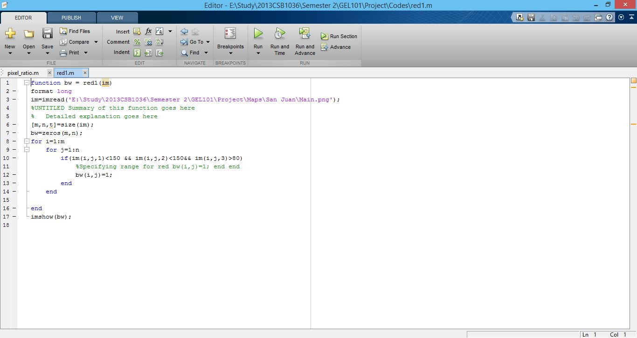

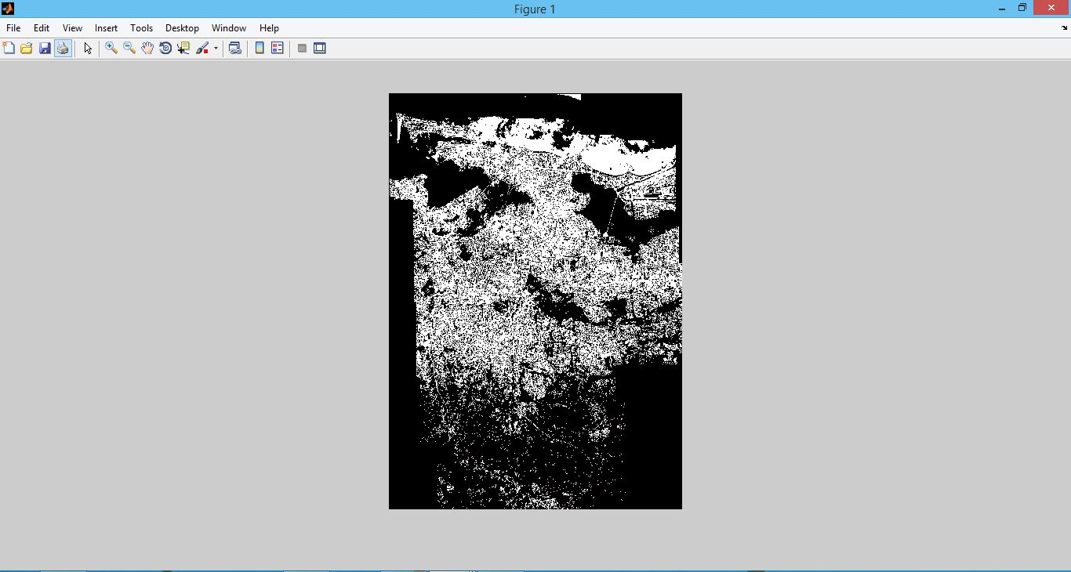

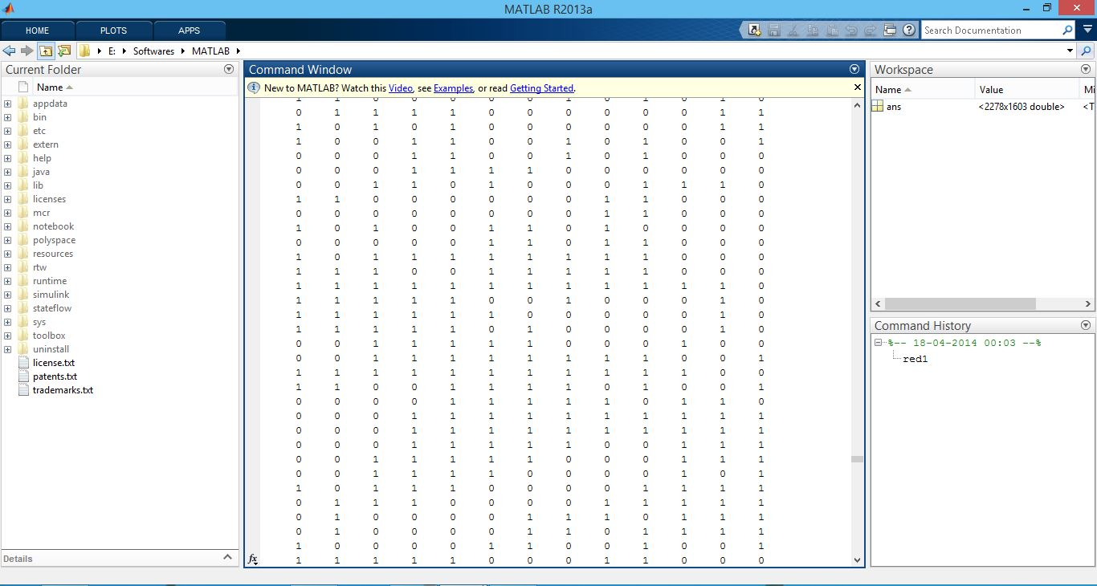

1. After calculating the number of pixels for a color, the fraction of color is determined by dividing with the total number of pixels. Some extra fraction is obtained due to outer area of the city. This extra fraction is obtained using Photoshop. The exact fraction of color is obtained by taking the difference of the two.
2. The above steps are applied for all the colors. This completes the determination of percentage of colors using MATLAB.
3. **Determination of percentage of colors using Photoshop**
4. The combined map was opened in Adobe Photoshop and pixels for the required color were selected using the Magic Wand Tool and the Polygonal Lasso Tool. Then the histogram was drawn using the Histogram Tool. The histogram showed the selected number of pixels. The fraction of selected color was obtained by dividing the number of pixels o the color with total number of pixels in the image. The images shown below show the histogram of an image and usage of Magic Wand Tool and the Polygonal Lasso Tool.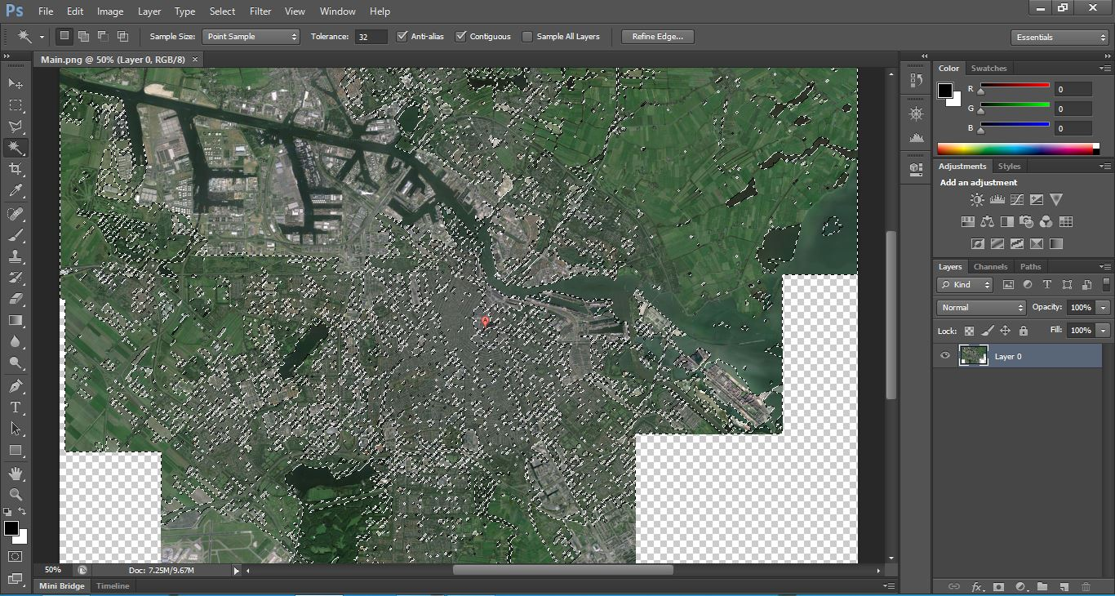

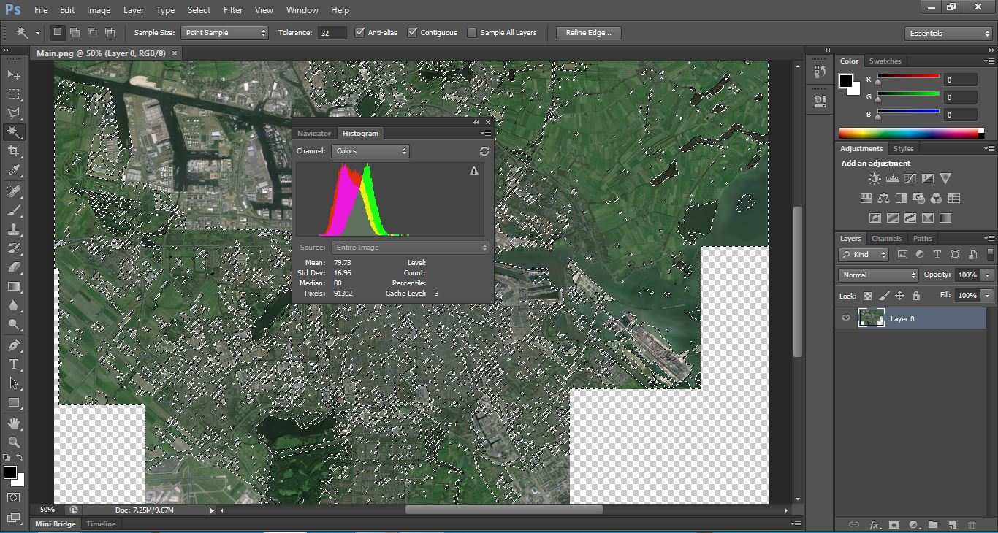

# **3. Comparative Results of 45 CITIES**

|  |  |  |  |  |
| --- | --- | --- | --- | --- |
| S. No. | Name Of The City | Country | Population | Area (in km2) |
| 1. | Chandigarh | India | 10,54,686 | 114 |
| 2. | Mumbai | India | 1,24,78,447 | 603 |
| 3. | Agra | India | 17,46,467 | 118.40 |
| 4. | Srinagar | India | 12,73,312 | 294 |
| 5. | Ranchi | India | 11,26,741 | 175 |
| 6. | Kota | India | 10,01,365 | 318 |
| 7. | Pune | India | 60,49,968 | 710 |
| 8. | Zurich | Switzerland | 3,66,765 | 87.88 |
| 9. | Dublin | Ireland | 11,10,627 | 318 |
| 10. | San Juan | Puerto Rico | 3,95,326 | 119.2 |
| 11. | Kathmandu | Nepal | 7,00,000 | 50.67 |
| 12. | Damascus | Syria | 17,11,000 | 105 |
| 13. | Colombo | Sri Lanka | 6,47,100 | 37.31 |
| 14. | Buenos Aires | Argentina | 29,65,000 | 203.3 |
| 15. | Asuncion | Paraguay | 5,13,399 | 117.1 |
| 16. | Kuala Lumpur | Malaysia | 15,89,000 | 243 |
| 17. | Copenhagen | Denmark | 5,59,440 | 88.25 |
| 18. | Naypyidaw | Myanmar | 9,25,000 | 130 |
| 19. | Amsterdam | Netherlands | 7,79,808 | 219.32 |
| 20. | Munich | Germany | 26,06,021 | 310.43 |
| 21. | Reykjavik | Iceland | 1,18,488 | 274.5 |
| 22. | Brussels | Belgium | 11,38,854 | 161.38 |
| 23. | Athens | Greece | 37,52,973 | 412 |
| 24. | Asmara | Eritrea | 6,49,000 | 469.43 |
| 25. | Doha | Qatar | 7,96,947 | 132.1 |
| 26. | Shanghai | China | 2,17,66,000 | 6,340.5 |
| 27. | Istanbul | Turkey | 1,41,60,467 | 5,343 |
| 28. | Karachi | Pakistan | 1,35,50,000 | 3,527 |
| 29. | Moscow | Russia | 1,15,03,501 | 2,511 |
| 30. | Beijing | China | 1,17,16,000 | 1,368.32 |
| 31. | Sao Paulo | Brazil | 1,13,16,149 | 1,522.986 |
| 32. | Tianjin | China | 1,41,31,500 | 7,422 |
| 33. | Guangzhou | China | 1,10,70,654 | 3,843 |
| 34. | Delhi | India | 1,10,07,835 | 1,484 |
| 35. | Seoul | South Korea | 1,01,40,000 | 605.21 |
| 36. | Shenzhen | China | 1,05,47,400 | 1,952.84 |
| 37. | Jakarta | Indonesia | 95,88,198 | 7,641.51 |
| 38. | Tokyo | Japan | 1,31,85,502 | 2,187.66 |
| 39. | Mexico City | Mexico | 88,51,080 | 1,485 |
| 40. | New York City | United States | 84,05,837 | 1,413 |
| 41. | Dongguan | China | 82,20,237 | 2,465 |
| 42. | London | United Kingdom | 83,08,369 | 1,572 |
| 43. | Bangalore | India | 96,45,551 | 1,276 |
| 44. | Hyderabad | India | 68,09,970 | 650 |
| 45. | Ahmedabad | India | 62,70,156 | 464 |

**3.1 RESULTS USING MATLAB**

|  |  |  |  |  |  |  |
| --- | --- | --- | --- | --- | --- | --- |
| S. No. | Name Of The City | Country | Green | White | Blue | Others |
| 1. | Chandigarh | India | 32.47% | 21.15% | 15.43% | 30.95% |
| 2. | Mumbai | India | 25.54% | 56.19% | 1.56% | 16.71% |
| 3. | Agra | India | 27.90% | 63.05% | 6.39% | 2.66% |
| 4. | Srinagar | India | 33.70% | 52.53% | 10.41% | 3.36% |
| 5. | Ranchi | India | 11.23% | 15.45% | 5.98% | 67.34% |
| 6. | Kota | India | 15.68% | 67.58% | 4.59% | 12.15% |
| 7. | Pune | India | 18.17% | 67.21% | 13.47% | 1.15% |
| 8. | Zurich | Switzerland | 55.32% | 21.33% | 8.32% | 15.03% |
| 9. | Dublin | Ireland | 75.28% | 18.75% | 5.78% | 0.19% |
| 10. | San Juan | Puerto Rico | 48.38% | 32.31% | 10.35% | 8.96% |
| 11. | Kathmandu | Nepal | 13.00% | 84.55% | 1.41% | 1.04% |
| 12. | Damascus | Syria | 31.99% | 36.62% | 1.89% | 29.50% |
| 13. | Colombo | Sri Lanka | 15.85% | 67.26% | 10.86% | 6.03% |
| 14. | Buenos Aires | Argentina | 18.34% | 63.23% | 2.64% | 15.79% |
| 15. | Asuncion | Paraguay | 35.22% | 41.92% | 12.88% | 9.98% |
| 16. | Kuala Lumpur | Malaysia | 33.97% | 59.38% | 3.57% | 3.08% |
| 17. | Copenhagen | Denmark | 31.47% | 55.47% | 7.58% | 5.48% |
| 18. | Naypyidaw | Myanmar | 64.36% | 21.23% | 3.76% | 10.65% |
| 19. | Amsterdam | Netherlands | 51.49% | 36.43% | 3.92% | 8.16% |
| 20. | Munich | Germany | 49.91% | 46.04% | 3.69% | 0.36% |
| 21. | Reykjavik | Iceland | 26.61% | 27.34% | 27.66% | 18.39% |
| 22. | Brussels | Belgium | 51.55% | 45.01% | 2.38% | 1.06% |
| 23. | Athens | Greece | 19.53% | 75.23% | 4.87% | 0.37% |
| 24. | Asmara | Eritrea | 18.80% | 13.23% | 1.34% | 66.63% |
| 25. | Doha | Qatar | 12.35% | 54.79% | 13.63% | 19.23% |
| 26. | Shanghai | China | 42.24% | 26.96% | 4.82% | 25.98% |
| 27. | Istanbul | Turkey | 14.34% | 47.39% | 3.21% | 35.06% |
| 28. | Karachi | Pakistan | 15.87% | 75.21% | 2.59% | 6.33% |
| 29. | Moscow | Russia | 23.49% | 56.22% | 8.56% | 11.73% |
| 30. | Beijing | China | 47.32% | 34.86% | 1.68% | 16.14% |
| 31. | Sao Paulo | Brazil | 21.43% | 59.34% | 2.32% | 16.91% |
| 32. | Tianjin | China | 43.26% | 27.68% | 1.43% | 27.63% |
| 33. | Guangzhou | China | 51.82% | 28.59% | 0.65% | 18.94% |
| 34. | Delhi | India | 24.63% | 47.46% | 4.32% | 23.59% |
| 35. | Seoul | South Korea | 40.29% | 41.65% | 2.36% | 15.70% |
| 36. | Shenzhen | China | 42.56% | 34.30% | 5.36% | 17.78% |
| 37. | Jakarta | Indonesia | 20.69% | 54.36% | 3.91% | 21.04% |
| 38. | Tokyo | Japan | 11.78% | 66.38% | 1.62% | 20.22% |
| 39. | Mexico City | Mexico | 30.06% | 47.19% | 3.23% | 19.52% |
| 40. | New York City | United States | 14.83% | 46.09% | 8.66% | 30.42% |
| 41. | Dongguan | China | 40.55% | 30.88% | 2.10% | 26.47% |
| 42. | London | United Kingdom | 13.26% | 57.11% | 8.64% | 20.99% |
| 43. | Bangalore | India | 21.30% | 53.61% | 1.01% | 24.08% |
| 44. | Hyderabad | India | 29.83% | 49.29% | 1.76% | 19.12% |
| 45. | Ahmedabad | India | 26.43% | 60.78% | 3.22% | 9.57% |

# **3.2 RESULTS USING PHOTOSHOP**

|  |  |  |  |  |  |  |
| --- | --- | --- | --- | --- | --- | --- |
| S. No. | Name Of The City | Country | Green | White | Blue | Others |
| 1. | Chandigarh | India | 42.28% | 17.24% | 11.40% | 29.08% |
| 2. | Mumbai | India | 22.56% | 56.68% | 3.25% | 17.91% |
| 3. | Agra | India | 31.33% | 60.72% | 5.04% | 2.91% |
| 4. | Srinagar | India | 35.30% | 50.64% | 8.87% | 5.19% |
| 5. | Ranchi | India | 9.69% | 16.46% | 2.21% | 71.64% |
| 6. | Kota | India | 19.31% | 62.46% | 3.90% | 14.33% |
| 7. | Pune | India | 22.40% | 65.18% | 8.75% | 3.67% |
| 8. | Zurich | Switzerland | 54.74% | 28.86% | 3.40% | 13.00% |
| 9. | Dublin | Ireland | 71.10% | 17.12% | 9.40% | 2.38% |
| 10. | San Juan | Puerto Rico | 46.23% | 34.93% | 15.29% | 3.55% |
| 11. | Kathmandu | Nepal | 12.36% | 84.93% | 0.32% | 2.39% |
| 12. | Damascus | Syria | 28.41% | 35.96% | 0.24% | 36.39% |
| 13. | Colombo | Sri Lanka | 11.26% | 70.84% | 6.10% | 11.80% |
| 14. | Buenos Aires | Argentina | 13.08% | 69.20% | 3.42% | 14.30% |
| 15. | Asuncion | Paraguay | 31.94% | 45.74% | 8.46% | 13.86% |
| 16. | Kuala Lumpur | Malaysia | 36.15% | 55.12% | 6.30% | 2.43% |
| 17. | Copenhagen | Denmark | 27.69% | 60.87% | 6.26% | 5.18% |
| 18. | Naypyidaw | Myanmar | 64.83% | 27.20% | 0.70% | 7.27% |
| 19. | Amsterdam | Netherlands | 45.87% | 36.56% | 6.65% | 10.92% |
| 20. | Munich | Germany | 48.25% | 49.72% | 1.48% | 0.55% |
| 21. | Reykjavik | Iceland | 24.27% | 22.80% | 35.29% | 17.64% |
| 22. | Brussels | Belgium | 49.98% | 43.86% | 3.99% | 2.17% |
| 23. | Athens | Greece | 14.11% | 76.75% | 2.28% | 6.86% |
| 24. | Asmara | Eritrea | 9.15% | 12.82% | 0.80% | 77.23% |
| 25. | Doha | Qatar | 14.21% | 50.09% | 10.48% | 25.22% |
| 26. | Shanghai | China | 37.42% | 29.06% | 3.09% | 30.43% |
| 27. | Istanbul | Turkey | 19.56% | 56.92% | 8.69% | 14.83% |
| 28. | Karachi | Pakistan | 24.33% | 69.41% | 4.81% | 1.45% |
| 29. | Moscow | Russia | 26.44% | 50.16% | 4.79% | 18.61% |
| 30. | Beijing | China | 40.78% | 38.93% | 5.38% | 14.91% |
| 31. | Sao Paulo | Brazil | 27.10% | 50.03% | 1.33% | 21.54% |
| 32. | Tianjin | China | 56.48% | 23.21% | 2.43% | 17.52% |
| 33. | Guangzhou | China | 44.89% | 34.12% | 2.38% | 18.61% |
| 34. | Delhi | India | 26.27% | 40.72% | 5.18% | 27.83% |
| 35. | Seoul | South Korea | 47.41% | 43.97% | 3.68% | 4.94% |
| 36. | Shenzhen | China | 44.08% | 37.13% | 2.44% | 16.35% |
| 37. | Jakarta | Indonesia | 29.20% | 47.92% | 2.02% | 20.86% |
| 38. | Tokyo | Japan | 22.16% | 54.25% | 3.41% | 20.18% |
| 39. | Mexico City | Mexico | 24.81% | 54.23% | 5.17% | 15.79% |
| 40. | New York City | United States | 23.44% | 40.13% | 5.80% | 30.63% |
| 41. | Dongguan | China | 42.12% | 34.67% | 1.56% | 21.65% |
| 42. | London | United Kingdom | 20.43% | 49.57% | 6.20% | 23.80% |
| 43. | Bangalore | India | 17.11% | 58.32% | 0.32% | 24.25% |
| 44. | Hyderabad | India | 23.47% | 51.96% | 1.02% | 23.55% |
| 45. | Ahmedabad | India | 29.78% | 53.87% | 5.41% | 10.94% |

# **3.3 Error Analysis**

The percentage error in a color is calculated by taking the absolute value of the difference between the results obtained for that color using MATLAB and that using Photoshop.

|  |  |  |  |  |  |  |  |  |
| --- | --- | --- | --- | --- | --- | --- | --- | --- |
| S. No. | Name Of The City | Country | Green | White | Blue | Others | Mean Error | Standard Deviation |
| 1. | Chandigarh | India | 9.81% | 3.91% | 4.03% | 1.87% | 4.91% | 2.96 |
| 2. | Mumbai | India | 2.98% | 0.49% | 1.69% | 1.20% | 1.59% | 0.91 |
| 3. | Agra | India | 3.43% | 2.33% | 1.35% | 0.25% | 1.84% | 1.18 |
| 4. | Srinagar | India | 1.60% | 1.89% | 1.54% | 1.83% | 1.72% | 0.15 |
| 5. | Ranchi | India | 1.54% | 1.01% | 3.77% | 4.30% | 2.66% | 1.41 |
| 6. | Kota | India | 3.63% | 5.12% | 0.69% | 2.18% | 2.91% | 1.65 |
| 7. | Pune | India | 4.23% | 2.03% | 4.72% | 2.52% | 3.38% | 1.13 |
| 8. | Zurich | Switzerland | 0.58% | 7.53% | 4.92% | 2.03% | 3.77% | 2.68 |
| 9. | Dublin | Ireland | 4.18% | 1.63% | 3.62% | 2.19% | 2.91% | 1.03 |
| 10. | San Juan | Puerto Rico | 2.15% | 2.62% | 4.94% | 5.41% | 3.78% | 1.41 |
| 11. | Kathmandu | Nepal | 0.64% | 0.38% | 1.09% | 1.35% | 0.87% | 0.38 |
| 12. | Damascus | Syria | 3.58% | 0.66% | 1.65% | 6.89% | 3.20% | 2.38 |
| 13. | Colombo | Sri Lanka | 4.59% | 3.58% | 4.76% | 5.77% | 4.68% | 0.78 |
| 14. | Buenos Aires | Argentina | 5.26% | 5.97% | 0.78% | 1.49% | 3.38% | 2.27 |
| 15. | Asuncion | Paraguay | 3.28% | 3.82% | 4.42% | 3.88% | 3.85% | 0.40 |
| 16. | Kuala Lumpur | Malaysia | 2.18% | 4.26% | 2.73% | 0.65% | 2.46% | 1.29 |
| 17. | Copenhagen | Denmark | 3.78% | 5.40% | 1.32% | 0.30% | 2.70% | 2.01 |
| 18. | Naypyidaw | Myanmar | 0.47% | 5.97% | 3.06% | 3.38% | 3.22% | 1.95 |
| 19. | Amsterdam | Netherlands | 5.62% | 0.13% | 2.73% | 2.76% | 2.81% | 1.94 |
| 20. | Munich | Germany | 1.66% | 3.68% | 2.21% | 0.19% | 1.94% | 1.25 |
| 21. | Reykjavik | Iceland | 2.34% | 4.54% | 7.63% | 0.75% | 3.82% | 2.58 |
| 22. | Brussels | Belgium | 1.57% | 1.15% | 1.61% | 1.11% | 1.36% | 0.23 |
| 23. | Athens | Greece | 5.42% | 1.52% | 2.59% | 6.49% | 4.01% | 2.02 |
| 24. | Asmara | Eritrea | 9.65% | 0.41% | 0.54% | 10.60% | 5.30% | 4.84 |
| 25. | Doha | Qatar | 1.86% | 4.70% | 3.15% | 5.99% | 3.93% | 1.56 |
| 26. | Shanghai | China | 4.82% | 2.10% | 1.73% | 4.45% | 3.28% | 1.37 |
| 27. | Istanbul | Turkey | 5.22% | 9.53% | 5.48% | 20.23% | 10.12% | 6.08 |
| 28. | Karachi | Pakistan | 8.46% | 5.80% | 2.22% | 4.88% | 5.34% | 2.23 |
| 29. | Moscow | Russia | 2.95% | 6.06% | 3.77% | 6.88% | 4.92% | 1.61 |
| 30. | Beijing | China | 6.54% | 4.07% | 3.70% | 1.23% | 3.89% | 1.88 |
| 31. | Sao Paulo | Brazil | 5.67% | 9.31% | 0.99% | 4.63% | 5.15% | 2.96 |
| 32. | Tianjin | China | 13.22% | 4.47% | 1.00% | 10.11% | 7.20% | 4.76 |
| 33. | Guangzhou | China | 6.93% | 5.53% | 1.73% | 0.33% | 3.63% | 2.69 |
| 34. | Delhi | India | 1.64% | 6.74% | 0.86% | 4.24% | 3.37% | 2.31 |
| 35. | Seoul | South Korea | 7.12% | 2.32% | 1.32% | 10.76% | 5.38% | 3.80 |
| 36. | Shenzhen | China | 1.52% | 2.83% | 2.92% | 1.43% | 2.18% | 0.70 |
| 37. | Jakarta | Indonesia | 8.51% | 6.44% | 1.89% | 0.18% | 4.26% | 3.36 |
| 38. | Tokyo | Japan | 10.38% | 12.13% | 1.79% | 0.04% | 6.09% | 5.24 |
| 39. | Mexico City | Mexico | 5.25% | 7.04% | 1.94% | 3.73% | 4.49% | 1.88 |
| 40. | New York City | United States | 8.61% | 5.96% | 2.86% | 0.21% | 4.41% | 3.17 |
| 41. | Dongguan | China | 1.57% | 3.79% | 0.54% | 4.82% | 2.68% | 1.70 |
| 42. | London | United Kingdom | 7.17% | 7.54% | 2.44% | 2.81% | 4.99% | 2.37 |
| 43. | Bangalore | India | 4.19% | 4.71% | 0.69% | 0.17% | 2.44% | 2.03 |
| 44. | Hyderabad | India | 6.36% | 2.67% | 0.74% | 4.43% | 3.55% | 2.08 |
| 45. | Ahmedabad | India | 3.35% | 6.91% | 2.19% | 1.37% | 3.46% | 2.12 |

|  |  |  |
| --- | --- | --- |
| S.No. | Color | Mean Error for 45 Cities |
| 1. | Green | 4.57% |
| 2. | White | 4.24% |
| 3. | Blue | 2.50% |
| 4. | Others | 3.61% |

|  |  |
| --- | --- |
| Overall Mean Error for 45 Cities = 3.73% |  |

|  |
| --- |
| Overall Mean Standard Deviation for 45 Cities = 2.11 |

# **4. Interpretation Of Results**

The results obtained above cannot be judged as 100% wrong or 100% correct. But this report clearly indicates that some cities require to increase their green cover to be sustainable. Moreover, most of the cities have very less percentage of water bodies. With increase in globalization and modernization, more buildings are replacing the green cover of the city. The extent of urbanization is so much that decrease in green cover has led to global warming rendering many faunal species homeless.

Moreover, many species of flora and fauna are on the verge of extinction due to decrease in greenery.

The following table compares population and average greenery of a city. Average green percentage is calculated by taking the average of results from MATLAB and Photoshop.

|  |  |  |  |  |  |  |
| --- | --- | --- | --- | --- | --- | --- |
| S. No. | Name Of The City | Country | Average Green | Population | Area (in km2) | Area Under Green (in km2) |
| 1. | Chandigarh | India | 37.38% | 10,54,686 | 114 | 42.61 |
| 2. | Mumbai | India | 24.05% | 1,24,78,447 | 603 | 145.02 |
| 3. | Agra | India | 29.62% | 17,46,467 | 118.40 | 35.07 |
| 4. | Srinagar | India | 34.50% | 12,73,312 | 294 | 101.43 |
| 5. | Ranchi | India | 10.46% | 11,26,741 | 175 | 18.31 |
| 6. | Kota | India | 17.50% | 10,01,365 | 318 | 55.65 |
| 7. | Pune | India | 20.29% | 60,49,968 | 710 | 144.06 |
| 8. | Zurich | Switzerland | 55.03% | 3,66,765 | 87.88 | 48.36 |
| 9. | Dublin | Ireland | 73.19% | 11,10,627 | 318 | 232.74 |
| 10. | San Juan | Puerto Rico | 47.31% | 3,95,326 | 119.2 | 56.39 |
| 11. | Kathmandu | Nepal | 12.68% | 7,00,000 | 50.67 | 6.42 |
| 12. | Damascus | Syria | 30.20% | 17,11,000 | 105 | 31.71 |
| 13. | Colombo | Sri Lanka | 13.56% | 6,47,100 | 37.31 | 5.06 |
| 14. | Buenos Aires | Argentina | 15.71% | 29,65,000 | 203.3 | 31.94 |
| 15. | Asuncion | Paraguay | 33.58% | 5,13,399 | 117.1 | 39.32 |
| 16. | Kuala Lumpur | Malaysia | 35.06% | 15,89,000 | 243 | 85.20 |
| 17. | Copenhagen | Denmark | 29.58% | 5,59,440 | 88.25 | 26.10 |
| 18. | Naypyidaw | Myanmar | 64.60% | 9,25,000 | 130 | 83.98 |
| 19. | Amsterdam | Netherlands | 48.68% | 7,79,808 | 219.32 | 106.76 |
| 20. | Munich | Germany | 49.08% | 26,06,021 | 310.43 | 152.36 |
| 21. | Reykjavik | Iceland | 25.44% | 1,18,488 | 274.5 | 69.83 |
| 22. | Brussels | Belgium | 50.77% | 11,38,854 | 161.38 | 81.93 |
| 23. | Athens | Greece | 16.82% | 37,52,973 | 412 | 69.30 |
| 24. | Asmara | Eritrea | 13.98% | 6,49,000 | 469.43 | 65.63 |
| 25. | Doha | Qatar | 13.28% | 7,96,947 | 132.1 | 17.54 |
| 26. | Shanghai | China | 39.83% | 2,17,66,000 | 6,340.5 | 2525.42 |
| 27. | Istanbul | Turkey | 16.95% | 1,41,60,467 | 5,343 | 905.64 |
| 28. | Karachi | Pakistan | 20.10% | 1,35,50,000 | 3,527 | 708.93 |
| 29. | Moscow | Russia | 24.97% | 1,15,03,501 | 2,511 | 627.00 |
| 30. | Beijing | China | 44.05% | 1,17,16,000 | 1,368.32 | 602.74 |
| 31. | Sao Paulo | Brazil | 24.27% | 1,13,16,149 | 1,522.98 | 369.63 |
| 32. | Tianjin | China | 49.87% | 1,41,31,500 | 7,422 | 3701.35 |
| 33. | Guangzhou | China | 48.36% | 1,10,70,654 | 3,843 | 1858.47 |
| 34. | Delhi | India | 25.45% | 1,10,07,835 | 1,484 | 377.68 |
| 35. | Seoul | South Korea | 43.85% | 1,01,40,000 | 605.21 | 265.38 |
| 36. | Shenzhen | China | 43.32% | 1,05,47,400 | 1,952.84 | 845.97 |
| 37. | Jakarta | Indonesia | 24.95% | 95,88,198 | 7,641.51 | 1906.56 |
| 38. | Tokyo | Japan | 16.97% | 1,31,85,502 | 2,187.66 | 371.25 |
| 39. | Mexico City | Mexico | 27.44% | 88,51,080 | 1,485 | 407.48 |
| 40. | New York City | United States | 19.14% | 84,05,837 | 1,413 | 270.45 |
| 41. | Dongguan | China | 41.34% | 82,20,237 | 2,465 | 1019.03 |
| 42. | London | United Kingdom | 16.85% | 83,08,369 | 1,572 | 264.88 |
| 43. | Bangalore | India | 19.21% | 96,45,551 | 1,276 | 245.12 |
| 44. | Hyderabad | India | 26.65% | 68,09,970 | 650 | 173.23 |
| 45. | Ahmedabad | India | 28.11% | 62,70,156 | 464 | 130.43 |

From the table, we see that among the 21 most populous cities, Tianjin has the highest green percentage with 49.87%.

# **5. Conclusion**

Thus, from the tables and the graphs, it was observed that Tianjin has the highest green percentage with 49.87% among the 21 most populous cities while London has the lowest green percentage with 16.85%. But when we compare between the 45 cities taken in the project, Dublin has the highest green percentage with 73.19% while Ranchi has the lowest green percentage with 10.46%.

It’s been estimated that urban areas will be more than double in size by 2030. With proper measures, this growth can greatly improve the quality of life for those living in cities.

Some of these measures are to increase parks, trees, and rooftop gardens and greenery. These actions can, somewhat surprisingly, go a long way towards decreasing city population, as well as helping to protect local plants and animals. This is considered especially important in rapidly growing nations like China and India, where city growth can occur practically overnight.

# **6. references**

The following references were used in the project or in the report:-

1. <http://cleantechnica.com/2012/10/16/cities-will-greatly-benefit-from-more-greenery-as-urban-areas-rapidly-expand-un-report-finds/>

2. <http://en.wikipedia.org/wiki/Global_warming>

3. <http://en.wikipedia.org/wiki/Sustainable_city>

4. Wikipedia

5. Google